Building MCP Client using LangGraph
Tools are something we use in our projects and while it is useful, it has a few inherent problems.
Example :- Let's say we want to connect our chatbot to GitHub and get information about pull requests. We would need to create a custom tool for that, which can become large and would mainly handle pull-request information.
If we later want information about issues, commits, repositories, or branches, we may need to create additional tools.
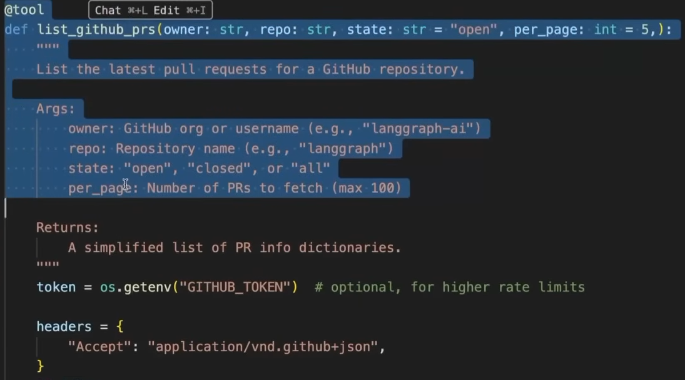
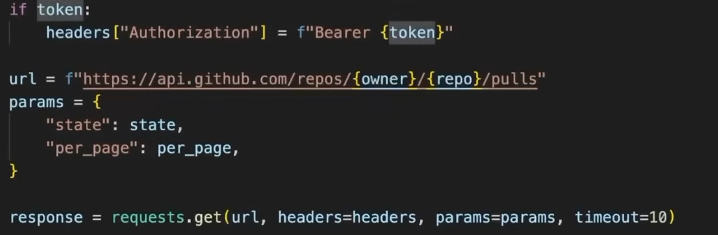
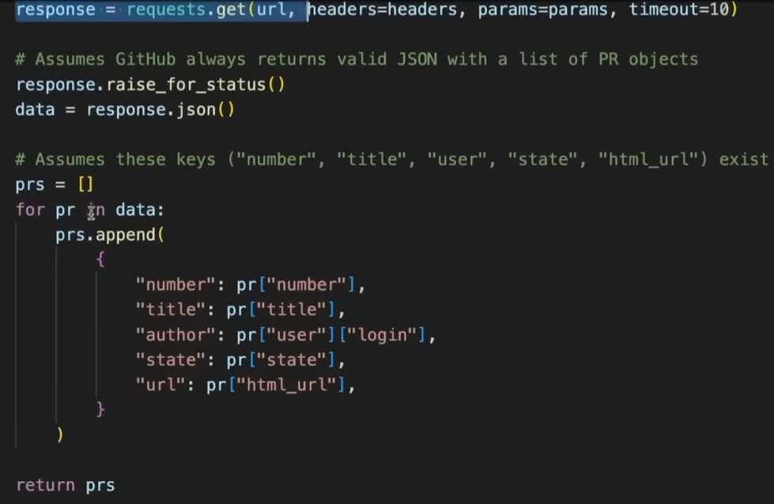
The second issue is maintenance. If GitHub changes its API, we have to update all the tools that depend on that API.
If we have N tools for GitHub and connect to M different platforms, API changes can lead to N × M updates which is huge.

This is where MCP comes into picture to solve these issues.
MCP is a standard protocol that allows an LLM to connect with external tools, data sources, and applications in a consistent way.
Instead of creating custom integrations for every tool, MCP provides a common interface through which the LLM can discover and use tools.
In MCP, we separate responsibilities:
- MCP Client → lives on the chatbot/AI application side.
  - Handles the connection to the MCP server.
  - Discovers the available tools.
  - Sends tool calls and receives results.
  - Doesn't need to implement GitHub-specific API logic.
- MCP Server → provides the tools/capabilities.
  - For example, a GitHub MCP server can provide tools for PRs, issues, commits, repositories, etc.
  - It handles the GitHub API details.

This code defines how the MCP client should connect to the GitHub MCP server.
Explanation:
- "github" → name of the MCP server.
- "transport": "stdio" → client and server communicate through standard input/output.
- "command": "/usr/bin/python3" → Python is used to start the server.
- "args" → arguments given to Python.
- "/path/to/github_mcp_server.py" → the actual MCP server program.
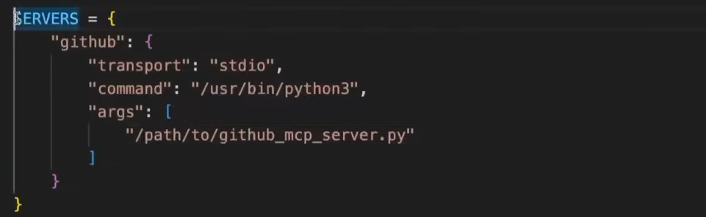

The MCP client library is designed around asynchronous operations, because MCP commonly involves communication with external servers and tools.

An async function is a function that can perform work without blocking the entire program while it waits for something, such as an API response, file operation, or network request.
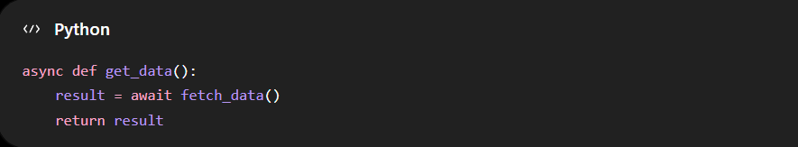
The async keyword tells Python:
“This function can pause while waiting for an operation and resume later.”

await is used inside an async function to wait for an asynchronous operation to finish.
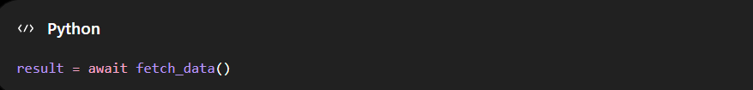
It means:
“Pause this function here until fetch_data() finishes, but allow other async work to run in the meantime.”

Our Basic ChatBot Code :- It is synchronous in nature
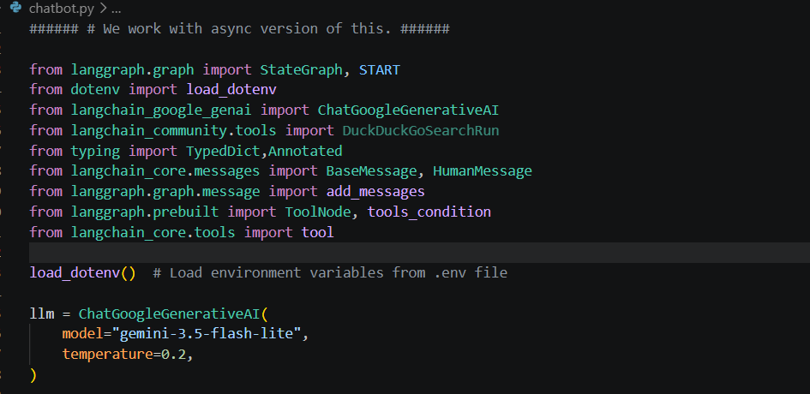

bind_tools() connects the LLM with the available tools so that the LLM knows which tools it can use and how to call them.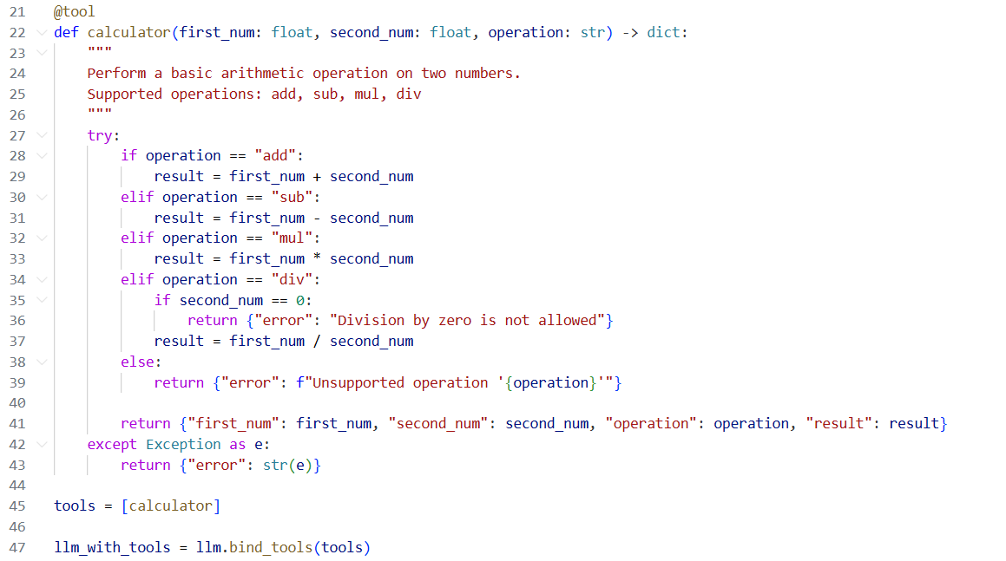
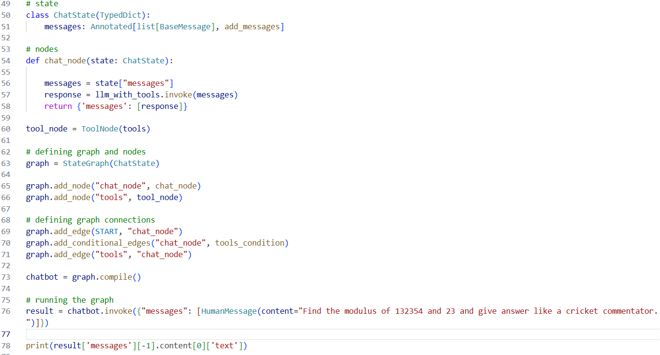

Result:-
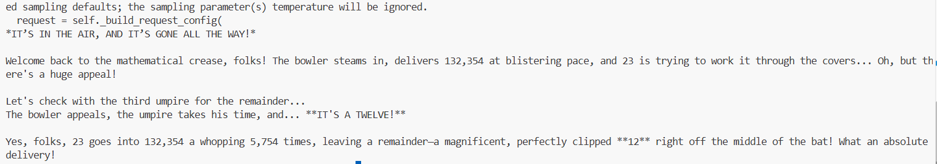
Code:-Since MCP operations work asynchronously, we make an async version of the code
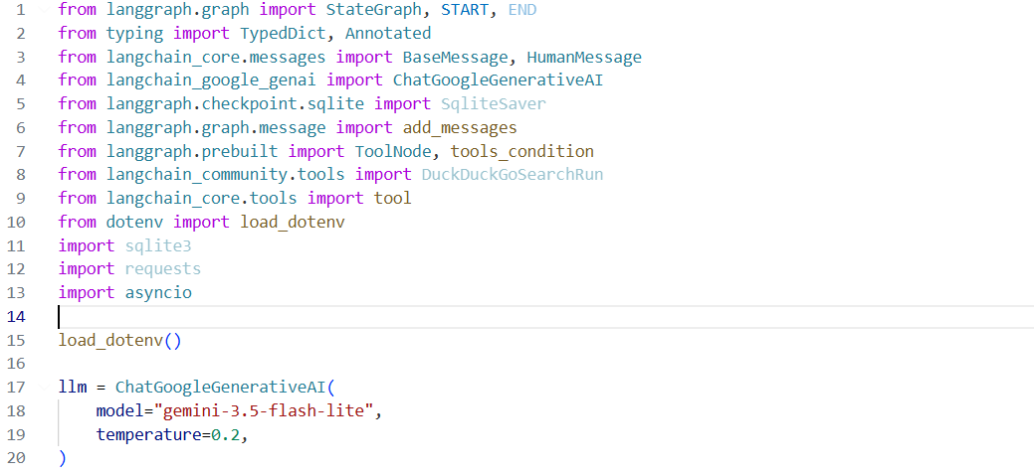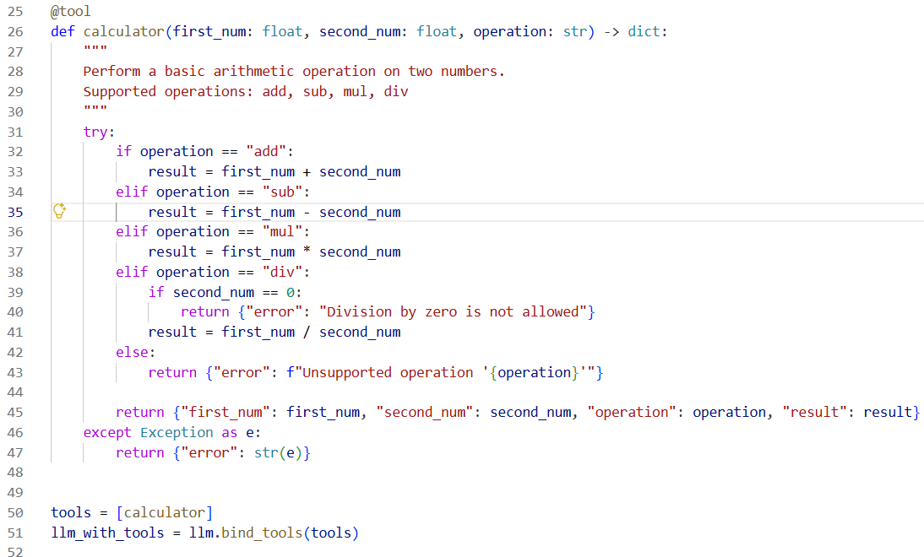
We created a build_graph() function and another function called chat_node() inside it, and made chat_node() asynchronous. We then used await when calling llm_with_tools, so it waits for the LLM to respond before moving forward. This is useful when there are multiple instructions in the same query, as some may finish faster than others. There is not much change apart from the fact that we put everything inside the build_graph() function.
Intuition:
async + await allows the program to wait for slower operations without blocking other asynchronous work, so tasks that finish faster do not have to unnecessarily wait for slower ones.
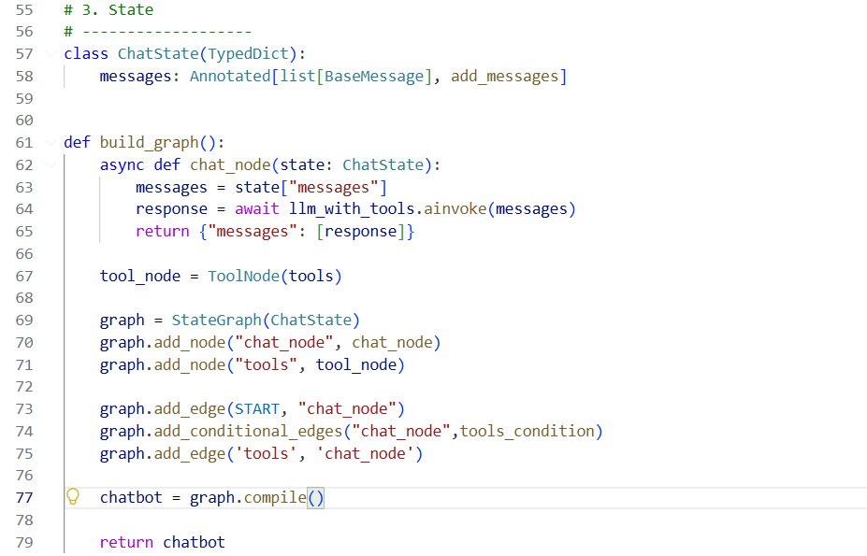
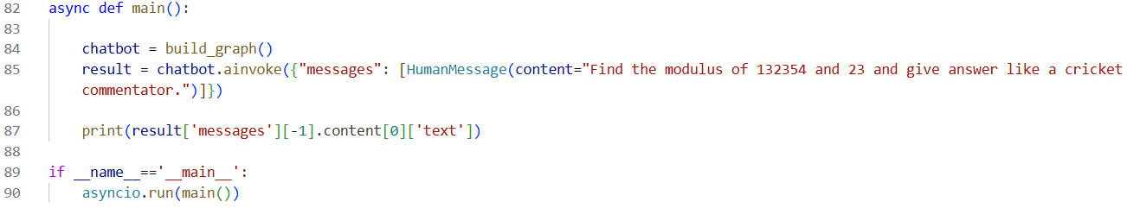
- async def main() → defines an asynchronous function.
- chatbot.ainvoke() → asynchronous version of invoke().
- await chatbot.ainvoke() → waits for the chatbot result without blocking other async tasks.
- asyncio.run(main()) → starts the async function and manages the event loop.

It gives the same response, but more importantly, we have only created an asynchronous version of the original code; it is not using MCP yet.
Chatbot using MCP Code :-
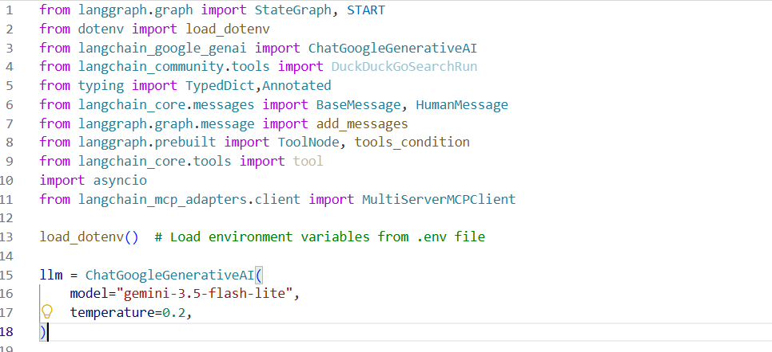

The transport variable specifies how the MCP client communicates with the MCP server, depending on where the server is running. If the MCP server is running locally, we can use stdio (standard input/output). If the MCP server is hosted remotely, such as on a FastMCP server that provides a URL, we use an appropriate network-based transport instead.
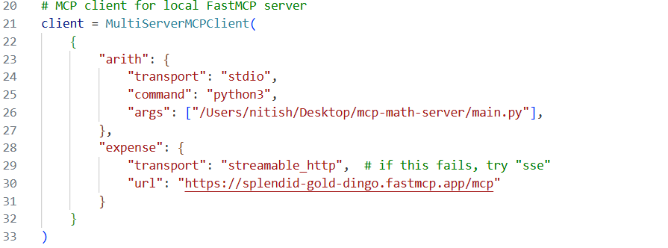
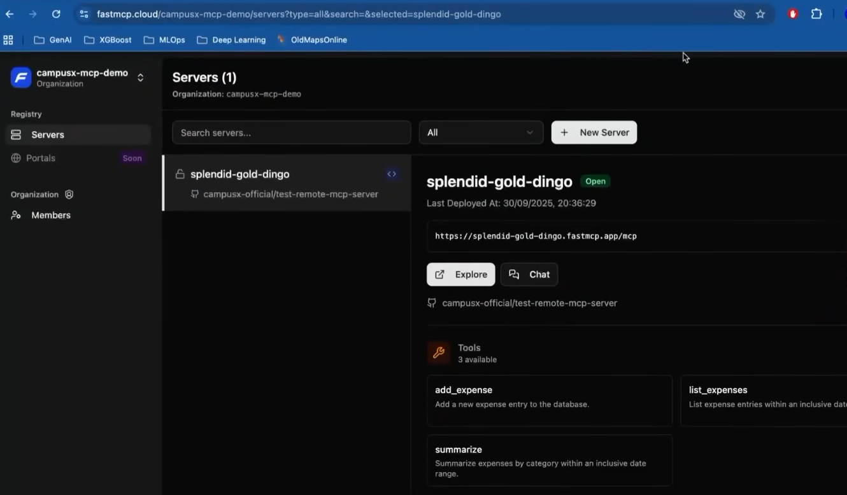
That is only change, everything else remains same.
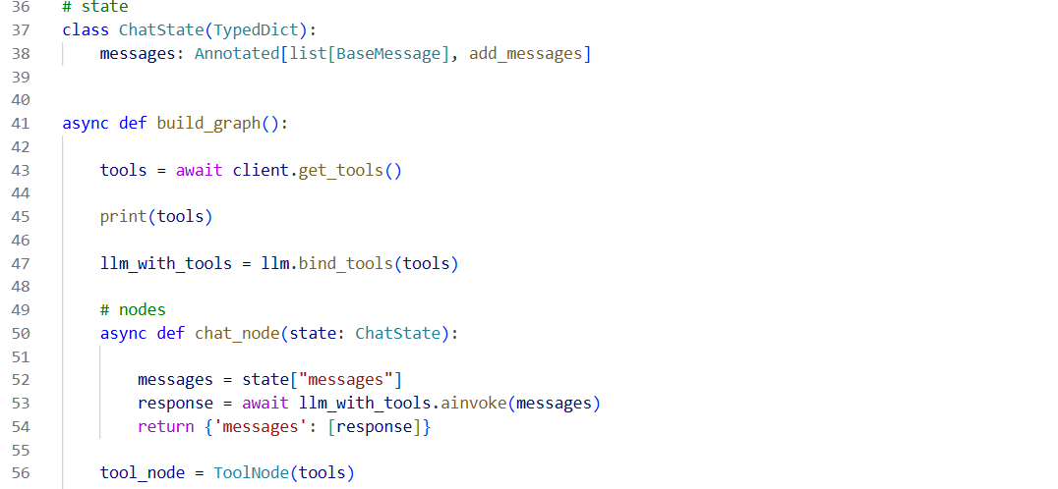
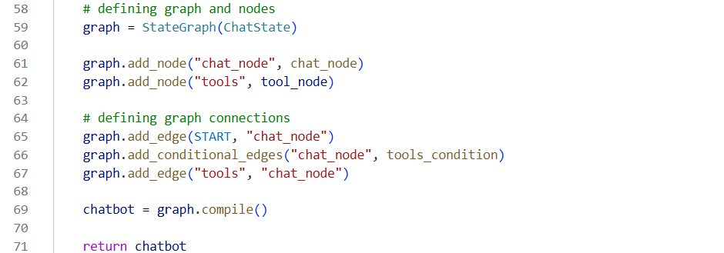
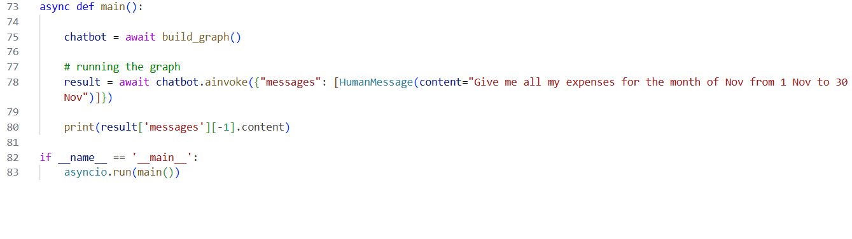
It is not necessary to use only tools or only MCP. We use both tools and MCP in same code. This allows LLM to use local tools as well as tools provided by MCP servers.
MCP Server Code:- This is currently running locally on our computer. Although it is not complete yet, we can see that we have created the tools here, which we can use.
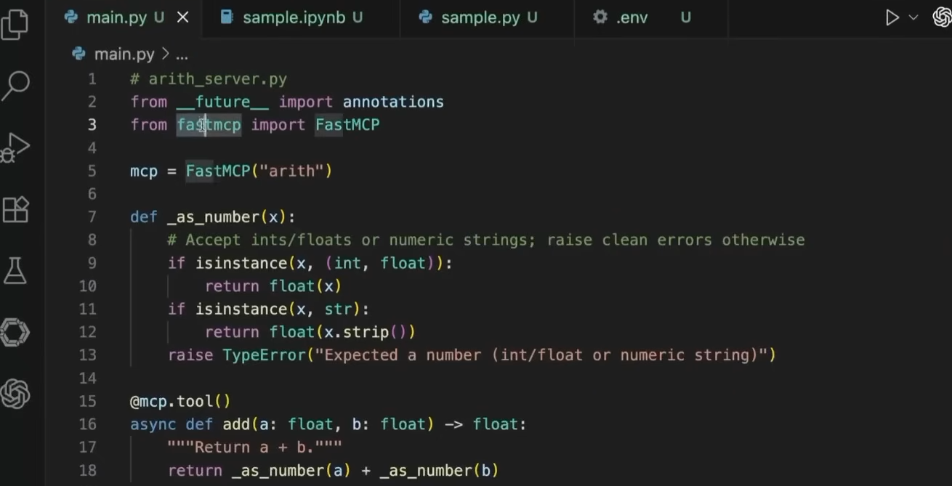
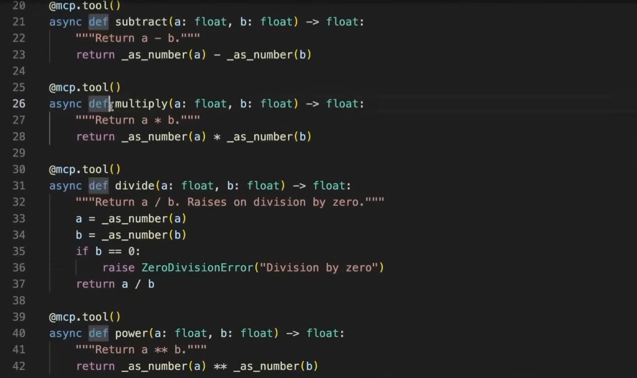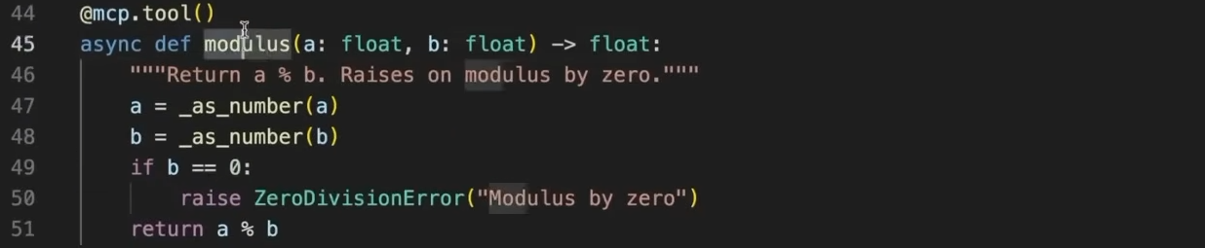

We can do this with our chatbot too. There is a small issue: we are using Streamlit, which is synchronous in nature, while MCP is asynchronous by nature. So, we need to use a small workaround to make them work together.
Intuition:
It is like connecting a synchronous application (Streamlit) with an asynchronous system (MCP), so we need a bridge between the two to handle the async operations properly.

Code for backend :-
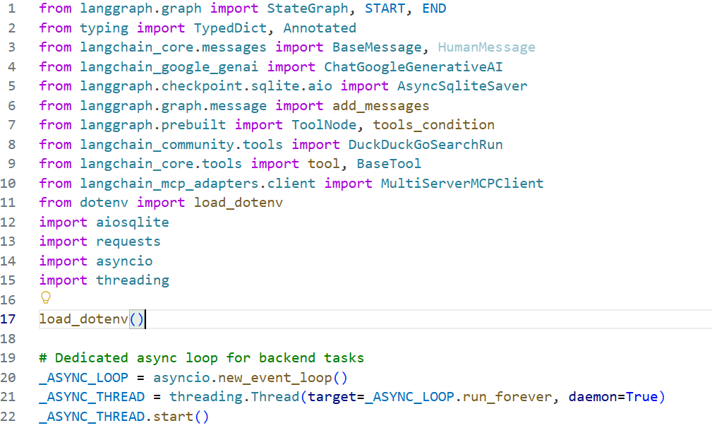
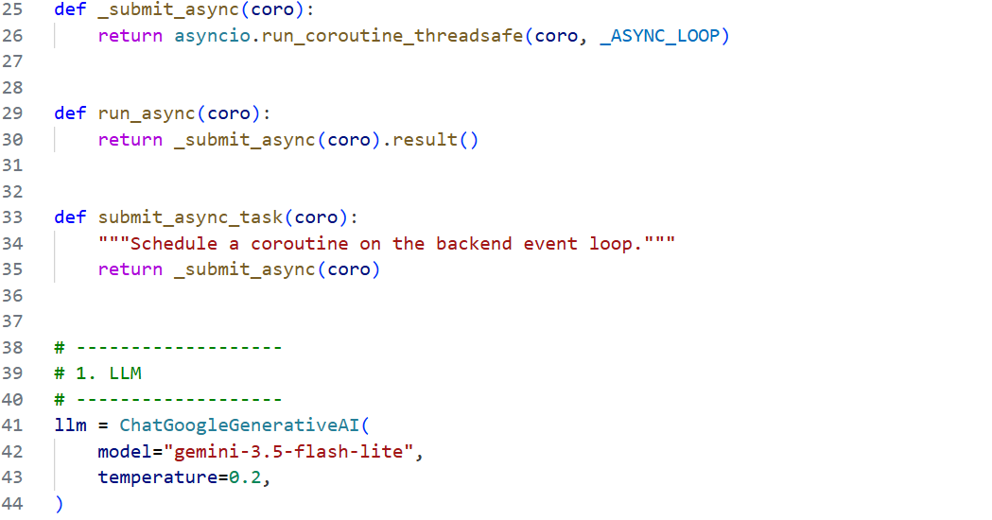

We are using three types of tools: one standard/pre-built tool, one custom tool that we created ourselves, and one tool provided through MCP.
Here, to add the MCP tools, we pass mcp_tools rather than just specifying a tool name. We created mcp_tools using the load_mcp_tools() function we defined earlier, which internally uses client.get_tools() to retrieve the tools available from the MCP server.
Intuition:
client.get_tools() fetches the available tools from the MCP server, and load_mcp_tools() stores/returns them as mcp_tools, which we can then provide to the LLM along with our other tools.
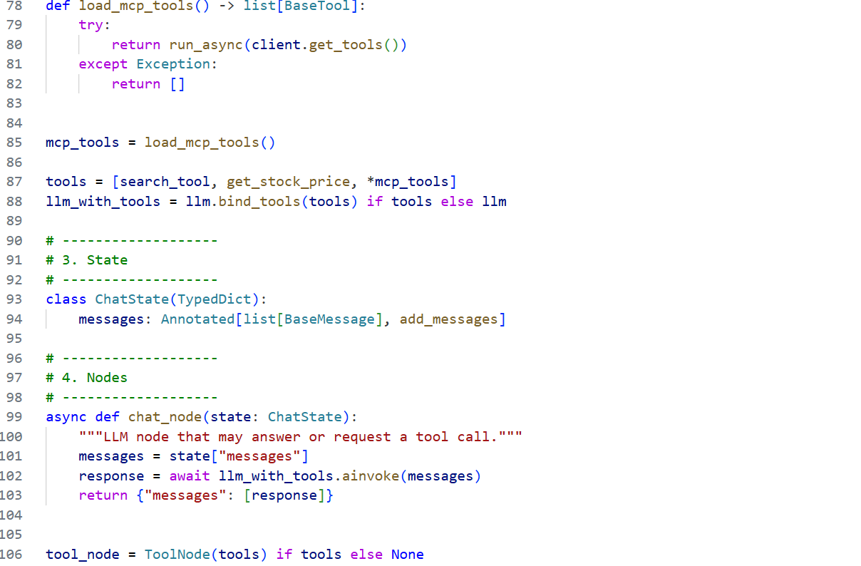

Here, we use aiosqlite rather than regular SQLite because aiosqlite is the asynchronous counterpart of the SQLite library. It allows SQLite database operations to work with our asynchronous code.
Intuition:
Just like invoke() → ainvoke(), we use the async version of SQLite so that the database operations fit into our async MCP/LangGraph workflow.
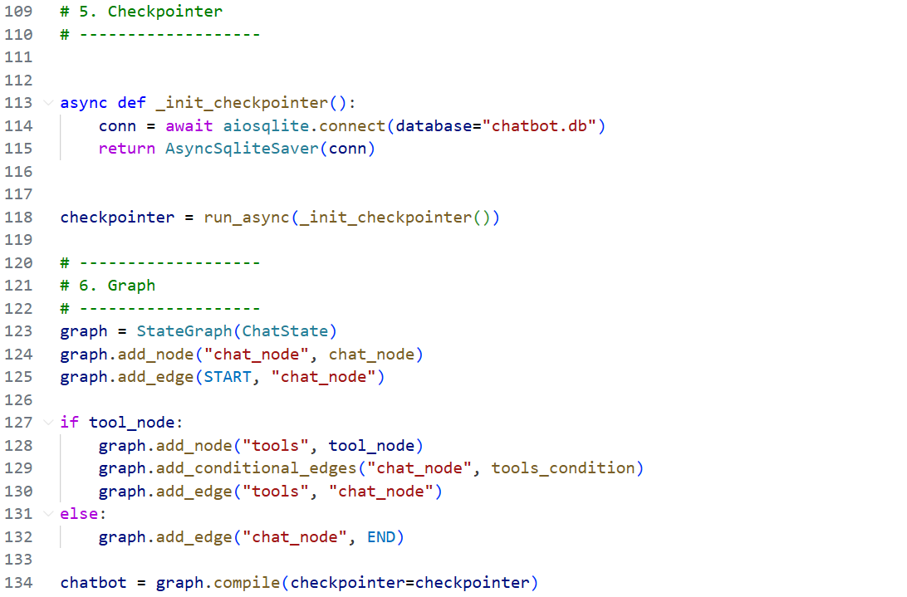
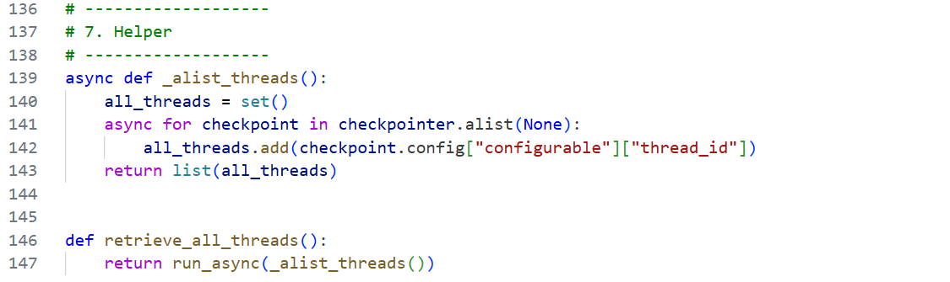

Front end for this Code :-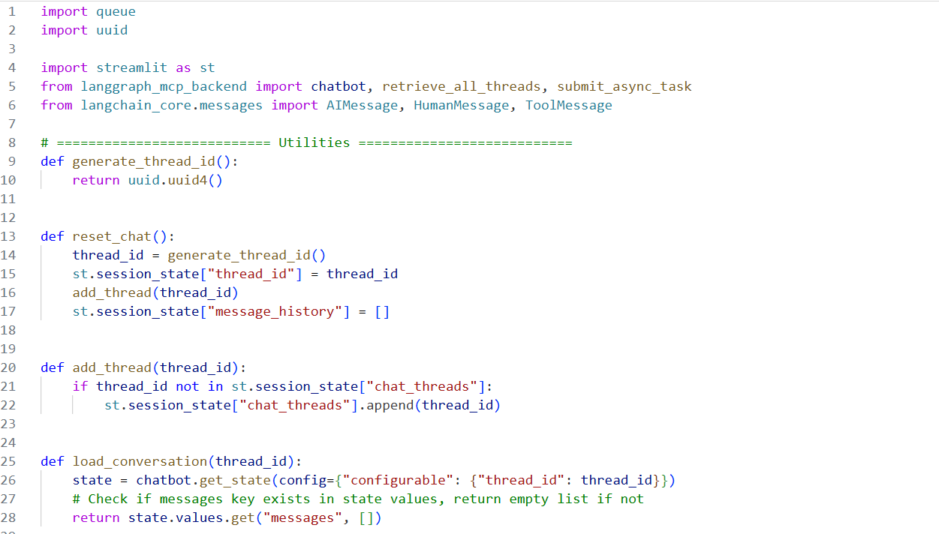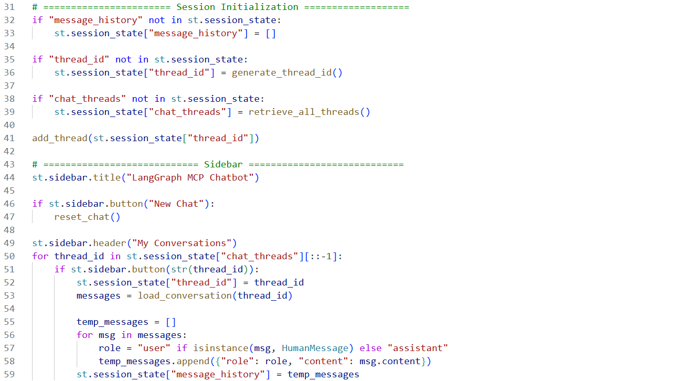
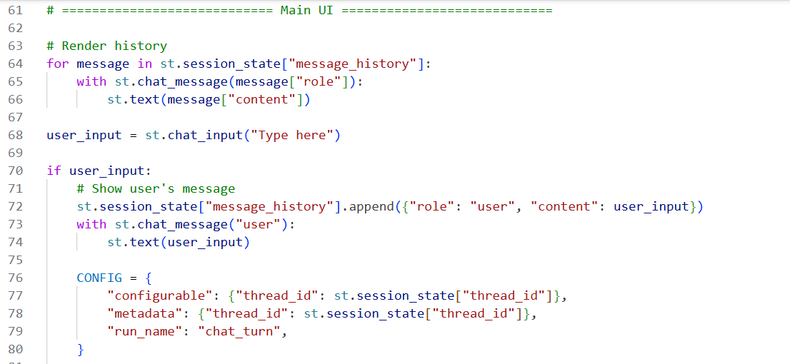
The only change here is that we used the asynchronous version of stream. That is the only change.
Intuition:
We are keeping the same streaming logic, but using its async version so it works with our asynchronous MCP workflow.
